ANNUAL REPORT FOR THE YEAR 2014-15

SIKKIM STATE ELECTRICITY REGULATORY COMMISSION

MAY 2015

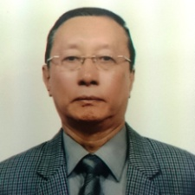
Shri. T.T Dorji

From the desk of the Chairperson

The Electricity Act, 2003 was enacted with the aim of reforming the electricity sector in the Country by ushering in openness, transparency and accountability. The Act is a mandate for the Regulators to work relentlessly for achieving the desired results as set out in the National Electricity Policy and Tariff Policy.

The onerous efforts of the various State Regulators have to a certain extent helped shape the electricity sector. Today, the electricity sector in the Country is developing at a much faster pace and electricity has started reaching the “poorest of the poor” and to the remotest parts of the Country. However, in terms of reliable 24x7 supply , reasonableness of price and quality of supply, much needs to be done especially in view of the fact that per capita consumption of electricity is an indicator of the progress and development of a nation. Changing of the mindset and the realization that it is the duty of all stake holders including the consumers to work collectively towards achieving the desired results is still found lacking and there is a long way to go both for the Regulators and the utilities.

The Government of India has given special thrust to the development of Renewable Energy in the Country. The Jawaharlal National Solar Mission has set a target of 20,000 MW by 2022. The target is huge and challenging but achievable. The concept of Grid Integrated Solar Power, though still at nascent stage, will go a long way in improving the overall power scenario in the Country by capacity addition. The onus lies on all the stake holders including the regulators to create both regulatory and institutional frameworks congenial for achieving the desired target and result.

Sikkim with a small population of around 6, 10,577 Lakhs as per the 2011 census has an annual power requirement within the State of around 270 MU and the State is comfortably placed so far as demand and supply scenario of electricity is concerned. The State is one of the greenest and cleanest States in India known for eco-tourism, peace & tranquillity and for being a total organic State. With limited natural mineral resources and without heavy industries, the main revenue earner for the State is tourism, hydropower and floriculture. Numerous big and small hydropower projects are being implemented in the State. The State will have huge surplus free power once all the projects are commissioned. The slowdown in investment in the hydropower sector in the recent years and the resultant set back to the pace of hydropower development in the Country might off-shoot the targeted power generation as envisioned both by the Government of India and the State Government. Although, no major challenges are seen in the near future so far as the power sector is concerned, there still remain challenges especially in the area of reduction in T&D losses, setting up of reliable transmission and distribution network, quality power supply etc. The Commission has been making efforts to help further the growth of the power sector in the State. The Officers and staffs of the Commission have been making untiring efforts to see that the aims and objectives as enshrined in the Electricity Act, 2003, the National Tariff Policy and the National Electricity Policy are achieved.

The Commission reiterates that it will continue making sustained efforts to take ahead the reforms agenda as prescribed by the Electricity Act, 2003. I take this opportunity to express my gratitude to all the Stake holders, the State Government, the Energy & Power Department, the members, staffs and officers of the Commission for their active participation and cooperation in taking forward the Regulatory process.

Sd/-
Gangtok, 8th May 2015 (T.T.Dorji), IAS (Retd.)
CHAIRPERSON

TABLE OF CONTENTS

Chapter No. | Particulars | Page Nos.
Chapter -1
1.1 | Introduction | 1
1.2 | Sikkim State Electricity Regulatory Commission | 1
Chapter- 2
2.1 | Activities of the Commission | 2
2.2 | Notification of Regulations | 2
2.3 | Determination of ARR and Tariff for F.Y 2014-15 | 3
2.4 | Public Hearing | 3
2.5 | Order for F.Y 2014-15 | 4
2.6 | Provisional True Up/Review for F.Y 2013-14 and F.Y 2014-15 | 5
2.7 | Fresh Directives for F.Y 2014-15 | 7
2.8 | Re-Constitution of the State Advisory Committee | 10
2.9 | Training and Capacity Building | 10
Chapter- 3
3.1 | Regulatory Disputes | 11
3.2 | Grant of Licence | 11
3.3 | Standards of Performance and Grievances Redressal | 11
3.4 | Adjudication of Disputes and Differences | 11
Chapter-4
4.1 | CAGR of Energy Sales and Specific Consumption in the State | 12
4.2 | Trajectory for Loss Reduction | 13
4.3 | Energy Requirement and Availability | 13
Annexure-I | Tariff Schedule for F.Y. 2014-15 | 14
Photo Gallery

CHAPTER – 1
1.1 INTRODUCTION
Sikkim is a remote sensitive landlocked Himalayan State with an area of 7096 SqKm and a population of 6,10,577 as per 2011 census. Owing to its small size and population, the requirement of power is also limited. The per capita energy consumption in the State was 328.36 KWh for 2013-14. Unlike other States in the Country, Sikkim does not have large or heavy industrial units or factories. There are only a few pharmaceutical units and small scale industries. As such, the major chunk of requirement of power requirement of the State comes from the Domestic Category. However, owing to the increasing economic development of the State, a slight growth in the Industrial category has been observed. The growth in power demand in the recent years are also attributable to the construction power requirements for numerous hydropower projects being constructed in the State. The EPDS is the only utility entrusted with the responsibility of transmission and distribution of electricity in the State of Sikkim. The EPDS is a deemed licensee under the provisions of Electricity Act, 2003, in the State of Sikkim.
The EPDS also own and operates a number of small hydropower projects and diesel generating stations. The EPDS also has a number of micro hydropower projects under execution. Thus the EPDS is also a power generator. Apart from the EPDS, the Sikkim Power Development Corporation Limited (SPDCL), A Government of Sikkim Enterprise also is engaged in the development of small hydropower projects in the State. The SPDCL presently owns and operates 3 (three) small hydropower projects with an installed capacity of 10 MW.
1.2 SIKKIM STATE ELECTRICITY REGULATORY COMMISSION
Sikkim State Electricity Regulatory Commission was constituted by the State Government on 15th day of November, 2003 vide Gazette Notification No.28/P/GEN/97/524 Dated 15.11.2003.The Commission is a one member Commission, who is the Chairperson. The Commission is presently in its 5th year of operation since the appointment of the Chairperson in April 2011. Presently, Shri. T.T. Dorji, IAS( Retd.) is holding the post of the Chairperson.

CHAPTER -2

2.1 ACTIVITIES OF THE COMMISSION

Although the Commission was constituted in November 2003, its actual operation could only start from April 2011 i.e. after the appointment of the first Chairperson. However, since then the Commission has come a long way and has been making unrelenting efforts to achieve the aims and objectives as envisaged in the Electricity Act (2003), the National Tariff Policy and National Electricity Policy. The Commission in its efforts towards making the power sector in the State more vibrant, investor friendly and providing a level playing field for all the stake holders has, to begin with, framed and notified several Regulations as mandated to it by the Electricity Act, 2003. The details of the various Regulations notified by the Commission is given hereunder:

2.2 NOTIFICATION OF REGULATIONS

The Commission has notified the following 12 Regulations till date. Few other Regulations have also been already framed by the Commission and have been sent for publication in the Government Gazette.

Sl.No | Name of the Regulations
1. | Sikkim State Electricity Regulatory Commission (Conduct of Business) Regulations, 2012.
2. | Sikkim State Electricity Regulatory Commission (Terms and Conditions for Determination of Tariff) Regulations, 2012.
3. | Sikkim State Electricity Regulatory Commission (Standards of Performance for the Distribution and Transmission Licensee) Regulations, 2012.
4. | Sikkim State Electricity Regulatory Commission (Electricity Supply Code) Regulations, 2012.
5. | Sikkim State Electricity Regulatory Commission (Redressal of Grievances of Consumers and Establishment of Forum of Electricity Ombudsman ) Regulations, 2012.
6. | Sikkim State Electricity Regulatory Commission (Terms and Conditions of Intra State Open Access) Regulations, 2012.
7. | Sikkim State Electricity Regulatory Commission (Terms and Conditions for Determination of Tariff for Generation from Renewable energy Sources) Regulations, 2012.
8. | Sikkim State Electricity Regulatory Commission (State Grid Code) Regulations, 2013.
9. | Sikkim State Electricity Regulatory Commission (Constitution of State Advisory) Regulations, 2012.
10. | Sikkim State Electricity Regulation Commission (Renewable Energy Purchase Obligations and Its Compliance) Regulations, 2012.
11. | Sikkim State Electricity Regulatory Commission (Constitution of State Advisory Committee and its Functions) Regulations, 2013
12. | Sikkim State Electricity Regulation Commission (Terms and Conditions for Determination of Tariff for Generation, Transmission, Wheeling and Distribution & Retail Supply under Multi Year Tariff Framework) Regulations, 2013

2.3 DETERMINATION OF ARR AND TARIFF FOR F.Y. 2014-15

The Energy & Power Department , Government of Sikkim, the deemed licensee for distribution of power in Sikkim filed its petition for Annual revenue Requirement and Tariff before the Commission for the F.Y. 2014-15. The petition was filed on 29.11.2013 and the petition was accepted and registered as Case No. TR-1/2014-15 on 10.12.2014.

The Commission had a series of communications and interactions with the Energy & Power Department. Several clarifications and additional information/data were sought from the Department on the ARR/Tariff petition.

2.4 PUBLIC HEARING

In view of the State/Parliamentary elections in progress in the State and model code of conduct issued by the State Election Commission, the Commission took appropriate action to obtain the formal clearance from the Office of the Chie Election Commission of India and Chief Electoral Office prior to conduct of the Public Hearing for determining the ARR and Tariff for F.Y 2014-15.

On receipt of the formal clearance to conduct the Public Hearing , the Commission directed the Energy & Power Department to publish a “Public Notice” giving the summary of the ARR and Tariff Proposal in accordance with Section 64 of the Electricity Act, 2003. The Department issued the Public Notice in two local newspapers and invited objections, suggestions and views of the consumers and stake holders. In response to the notice, only one written petition objecting the ARR/Tariff proposal was received. The Department filed its written response to the objection and requested the objector to take part in the Public Hearing to be conducted by the Commission.

As prescribed the Electricity Act, 2003 and Section 20 (1) of the Sikkim State Electricity Regulatory Commission (Terms and Conditions for Determination of Tariff) Regulations, 2012, the Commission held Public Hearings on 25.03.2014 and 26.03.2015 at Chintan, Bhawan, Gangtok, East Sikkim to solicit views, objections and suggestions of the consumers and stake holders. In order to ensure wide publicity about the Public Hearing, the Commission published the notice for the Public Hearing in four local newspapers intimating the general public,consumers and stake holders to participate in the Public Hearings.

The representatives of the Energy & Power Department responded to the various issues raised by the objectors/public and clarifying the doubts of the objectors. The Commission successfully conducted the Public Hearing and the views and objections raised by the public/stake holders as well as the response given by the Department in the Hearing were given a patient hearing.

2.5 ORDER FOR F.Y. 2014-15.

Although, the Commission had completed the entire process for determination of the ARR/Tariff including Public Hearing well within the stipulated time of 120 days from the date acceptance/registration of the Petition, the issue of Tariff Order was kept in abeyance as per the directives received from Chief Election Commission of India and State Election Commission in view of the State/Parliamentary elections in progress in the State and model code of conduct issued by the State Election Commission. The Commission after conducting prudence check, scrutiny of data/information and clarifications furnished by the Energy & Power Department issued the Tariff Order for F.Y 2014-15 on 15.04.2015 immediately after the model code of conduct was lifted by the State Election Commission. The Schedule of Tariff for F.Y. 2014-15 is placed at Annexure-I.The Commission felt that the Energy & Power Department (EPDS) needs to make efforts to make up the gap by improving the operational performance particularly through reduction of distribution losses which in turn would reduce the resource gap. The Commission observed that the outstanding arrears need to be recovered by the EPDS.Thee need to identify high end consumers in the State for increasing the energy demand in the State and the potential revenue from energy sales were also stressed by the Commission. The Commission also highlighted the need for the EPDS to make efforts to improve its own generation so that the State demand is met from its own generation. As such, the Commission did not propose for any hike in the Tariff for all categories of consumers for the F.Y 2014-15.
The details of the ARR/Revenue Gap approved by the Commission for F.Y. 2014-15 is presented in Table 1.1 hereunder.

Table 1.1: Aggregate Revenue Requirement approved by the Commission for

FY 2014-15 (Rs.Cr)
Sl.No | Particulars | Approved by the Commission | Actuals furnished by EPDS | Revised approved by Commission after True Up
1 | Cost of Fuel | 0.16 | 0.34 | 0.35
2 | Cost of Power Purchase | 176.65 | 176.65 | 173.70
3 | Employee Costs | 45.15 | 47.89 | 47.89
4 | R&M Expenses | 33.93 | 34.98 | 34.98
5 | Administration and General Expenses | 3.46 | 3.51 | 3.10
6 | Depreciation | 33.99 | 40.04 | 14.00
7 | Interest Charges | 62.80 | 67.81 | -
8 | Interest on Working Capital | 3.46 | 3.66 | 3.73
9 | Return on NFA/Equity | 29.67 | 34.48 | -
10 | Income Tax | 0.00 | 0.00 | -
11 | Total Revenue Requirement | 389.27 | 409.37 | 277.74
12 | Less: Non Tariff Income | 0.62 | 0.59 | 2.40
13 | Net Revenue Requirement | 388.64 | 408.78 | 275.34
14 | Revenue from Tariff | 102.54 | 108.74 | 111.70
15 | Revenue from Outside State Sale | 119.69 | 119.69 | 112.73
16 | Gap (13 - 14 – 15) | 166.42 | 180.35 | 50.92
17 | Gap for FY 2012-13 | 165.73 |  | -
18 | Gap for FY 2013-14 |  | 332.14 | -
19 | Total Gap (14+15) | 332.14 | 512.49 | 50.91
20 | Energy Sales within state |  | 255.79 | 264
21 | Energy Sales outside state |  | 411.72 | 388.73
23 | Average Cost of Supply (13/(19+20) Rs/Kwh |  | 6.12 | 4.22

The Revenue gap of Rs. 50.91 core arrived at above is based on projected data of FY 2014-15, which is about 18.50% of the ARR.

2.6 PROVISIONAL TRUE UP/REVIEW FOR F.Y 2012-13 AND F.Y 2013-14

The Commission after prudence check and detailed scrutiny of the Petition filed by the Energy & Power Department for Provisional True Up for F.Y 2012-13 and Review for F.Y 203-14, carried out the Provisional True Up/Review for F.Y. 2012-13 and F.Y 2013-14.

Based on the actuals furnished by the Department, the Commission considered and approved the provisional True Up for F.Y 2012-13 and Review for F.Y.2014-14. The ARR and Revenue Gap approved by the Commission for F.Y. 2012-13 and for F.Y 2013-14 after provisional True Up in the Tariff Order for F.Y 2014-15 are indicated below in Table 1.2 and Table 1.3 respectively.

Table 1.2 : Aggregate Revenue Requirement and Gap approved by the Commission

for FY 2012-13 (Provisional True Up)
(Rs.Cr)
Sl.No | Particulars | Approved by the Commission | Actuals furnished by EPDS | Revised approved by Commission after True Up
1 | Cost of Fuel | 0.85 | 0.17 | 0.17
2 | Cost of Power Purchase | 196.66 | 183.25 | 183.25
3 | Employee Costs | 52.21 | 42.72 | 42.72
4 | R&M Expenses | 8.60 | 32.30 | 32.30
5 | Admn & Gen. Expenses | 1.95 | 2.82 | 2.82
6 | Depreciation | 4.50 | 28.64 | 2.60
7 | Int & Fin Charges | 1.87 | 58.40 | -
8 | Int on W.C. | 3.46 | 3.09 | 6.10
9 | Return on Equity | - | 25.42 | -
10 | Total ARR | 270.10 | 376.82 | 269.96
11 | Less: Non Tariff Income | 15.19 | 1.91 | 15.19
12 | Net ARR | 254.91 | 374.91 | 254.77
13 | Revenue from Tariff | 82.14 | 89.49 | 89.49
14 | Revenue from outside sales | 47.60 | 119.69 | 119.69
15 | Gap | 125.17 | 165.73 | 45.59
Review for FY 2012-13 indicated that the revenue gap has been reduced to Rs. 45.59 crore as against Rs. 125.17 crore approved in tariff order dated 30.03.2012 for FY 2012-13.

Table 1.3: Aggregate Revenue Requirement and Gap for FY 2013-14
(Rs.Cr)
Sl.No | Particulars | Approved by the Commission | Actuals furnished by EPDS | Revised approved by Commission after True Up
1 | Cost of Fuel | 0.32 | 0.16 | 0.16
2 | Cost of Power Purchase | 212.30 | 176.65 | 176.65
3 | Employee Costs | 79.03 | 45.15 | 45.15
4 | R&M Expenses | 17.00 | 33.93 | 33.93
5 | Admn & Gen. Expenses | 3.71 | 3.46 | 3.46
6 | Depreciation | 11.66 | 33.99 | 7.94
7 | Int & Fin Charges | - | 62.80 | -
8 | Int on W.C. | - | 3.46 | 3.46
9 | Return on Equity | - | 29.67 | -
10 | Total ARR | 324.02 | 389.27 | 270.75
11 | Less: Non Tariff Income | 2.40 | 0.62 | 2.40
12 | Net ARR | 321.62 | 38.64 | 268.35
13 | Revenue from Tariff | 101.66 | 102.54 | 104.97
14 | Revenue from outside sales | 33.57 | 119.69 | 119.69
15 | Gap | 186.39 | 166.42 | 43.69
16 | Energy sales within the state | 271.59 | 241.19 | 237.49
17 | Energy sales outside state | 91.23 | 411.72 | 411.72
18 | Total Sales | 362.82 | 652.91 | 649.21

Review for FY 2013-14 indicated that the revenue gap has been reduced to Rs. 43.69 cr as against Rs. 186.39 crore approved in tariff order dated 30.03.2013 for F.Y 2013-14.
2.7 FRESH DIRECTIVES FOR F.Y 2014-15
The Commission reviewed the compliance of the various directives issued to the Energy b& Power Department in the past and issued the following fresh directives in the Tariff Order for F.Y 2014-15:
- Management Information System (MIS)
The EPDS has not maintained proper data in respect of sales (slab wise), with number of consumers and connected load / demand etc. for proper analysis of the past data based on actual and estimation of proper projections for consideration in the ARR. The EPDS is directed to take steps to build a credible and accurate data base and management information system (MIS) to meet the requirements for filing ARR & Tariff Petition as per regulatory requirement. The formats, software and hardware may be synchronized with the Regulatory Information and Management System (RIMS) circulated by Central Electricity Regulatory Commission (CERC).

- Replacement of Non-Functional / Defective Meters
Section 55 of the Electricity Act makes it mandatory for all consumers to have a meter installed at the place of residence / office. EPDS must ensure that all households in the State be properly metered. EPDS may like to avail of the assistance of the Government Undertakings like State Trading Corporation Sikkim (STCS) and Sikkim State Cooperative Supply and Marketing Federation (SIMFED) for making available standard meters that can be availed off by the consumers at a reasonable price. Metering is a pre-requisite for new service connection and EPDS is directed to complete 100% metering of consumers and shall ensure that no new service connections are provided unless metering is done. Installation of meter shall be a pre-requisite for any new service connection.
The EPDS has submitted report on % of defective meters as follow:
Bulk Supply 31.00%
HTS 7.23%
LTIS 13.11%
Commercial 11.08%
Domestic 20.42%

The situation is quite alarming. Latest information of non-functional meters may be obtained from the field offices and ensure that data is maintained correctly.

Replacement of meters shall be planned on priority wise i.e., meters of Bulk supply, commercial, industrial and high value domestic categories to be replaced on priority. In respect of defective meters billing may be done by adopting standard method. The Data on defective meters, replacement, and pendency shall be filed with the next petition.

- Consumer Contribution for Capital Investment
The fact of consumer contribution for capital investment is not brought out in the ARR and Tariff Petition.
The EPDS is directed to furnish the details of contributions being collected from consumers for capital works. The amounts collected from the consumers towards capital investment shall be brought out in the accounts. The depreciation and Return on Equity/ Capital Base should not be claimed on the amount contributed by the consumers towards capital investment.

- Investment Plan and approval of Capital Expenditure
Annual Investment Plan shall be submitted to the Commission and approval of Commission should be obtained for all major capital works costing Rs. 5.00 crore and above before execution of the works.

- Interest on Consumer Security Deposit
EPDS did not indicate the amount of security deposit collected from the consumers. EPDS is informed that as per section 47 (4) of IE Act 2003, the distribution licensee shall pay interest equivalent to bank rate or more as may be specified by the concerned state Commission on the consumer security deposit.

EPDS is therefore directed to maintain an account of the consumer-wise security deposit collected. Such data shall be furnished with the next filing invariably.

- Consumer Awareness/Sensitization
EPDS is directed to carry out “Consumer Awareness /Sensitization” campaigns so as to educate the consumers and the general Public on the various initiatives and subsidies announced by the government and manner of obtaining these benefits.

EPDS is also directed to create awareness and sensitize its employees on the need to be fully aware of various acts, rules & regulations, safety practices etc., EPDS may consider imparting trainings, arranging workshops etc., for its employees.

- Power Sector Reforms
Reforms in the Energy sector is absolutely necessary to overhaul the Energy sector to make it more vibrant and commercially viable in view of the huge Hydro power potential in the State. As part of the reforms envisaged the State Government will have to reconsider seriously the huge monopolistic role of the EPDS in the generation, transmission and distribution of electricity in the State. Most of the States have already initiated the process of unbundling their Energy / Power Departments/SEBs into separate corporate entities covering generation, transmission and distribution, even going to the extent of utilizing the private sector in the distribution of power. This is an important aspect that the State Government will have look at in order to ensure that the Power sector lives up to its expectation of becoming the State’s main revenue earner.

In addition the EPDS needs to examine and review the milestones agreed upon in the Memorandum of Understanding (MOU) signed with the Ministry of Power in December 2002 by the Government of Sikkim which have not been fully achieved. Necessary steps and actions need to be taken for achieving the target and commitment for implementation of reforms program in the power sector.

2.8 RE-CONSTITUTION OF THE STATE ADVISORY COMMITTEE
The Commission re-constituted the State Advisory Committee (SAC) in view of the resignation of one of the Members of the Committee Shri. K.C Pradhan, IAS (Retd.). The notification for re-constituting the SAC by inducting one new Member Shri.K.N.Bhutia, IAS (Retd.) was issued by the Commission vide Notification No. 02/SSERC/AC/2013-14/09 Dated 02.06.2014.The details of the Chairperson and the Members of the Committee are as indicated below:
- Shri. T.T. Dorji, IAS (Retd.) Chairperson of SSERC......Ex-Officio Chairperson
- Shri. P.K Pradahan , IAS (Retd.) Chief Secretary , Government of Sikkim..Member
- Shri. K.N Bhutia, IAS (Retd.) Principal Secretary, Government of Sikkim..Member
- Shri. O.P Singhi, (Retd) Secretary, Government of Sikkim..........................Member
- Shri. Taga Khampa, (Rtd.) Managing Director, ..........................................Member
Sikkim Time Corporation Ltd.
- Secretary, Food and Civil Supplies &Consumer
Affairs Department, Government of Sikkim...................................... Ex-Officio Member

2.9 TRAINING AND CAPACITY BUILDING

As a part of Capacity Building and Skill Development, the Commission nominated some of its Officers for attending various “Trainings” and “Workshops” conducted by the Forum of Regulators (FOR), South Asia Forum for Infrastructural Regulation (SAFIR) in different parts of the Country. The “training” and “workshops” in which the Commission’s officers took part are as follows:

Sl.No | Details of Training/Workshop | Date/Venue
1. | 12th Core Course of SAFIR on Regulatory Issues conducted by SAFIR and Bangladesh Institute of Administration | 23rd to 25th March 2014  Bangladesh
2. | 7th Capacity Building Program for Officers of Electricity Regulatory Commissions conducted by the FOR and IIT Kanpur. | 28th to 30th January 2015  IIT Kanpur.
3. | 8th Capacity Building Program for Officers of Electricity Regulatory Commissions conducted by the FOR and IIT Kanpur. | 18th to 20th February 2015-04-22  Singapore.
4. | National Workshop on Accelerating Clean Energy Deployment through Innovative Policies and Regulations organized by the MNRE,GoI and USAID/INDIA | 8th and 9th April 2015.  New Delhi.
5. | Step by Step Process involved in Tariff Determination conducted by Meghalaya Electricity regulatory Commission and Rachna Management Consultants & Studies Pvt. Ltd. | 16th to 18th April 2015  Shillong.

CHAPTER-3

3.1 REGULATORY DISPUTES

There were no regulatory disputes during the Financial Year 2013-14

3.2 GRANT OF LICENCE

The SSERC did not grant any licence during the period from April 2014-March 2015.

3.3 STANDARDS OF PERFORMANCE AND GRIEVANCE REDRESSAL

The Commission has monitored the compliance to the standard of performance by the deemed licensee i.e. Energy & Power Department, Government of Sikkim and also monitored the redressal of grievances by the Consumer Grievance Redressal Forum (CGRF) and Ombudsman.

The details of grievances and redressal during the FY 2014-15 are as given below:

Electricity Ombudsman
No. of Grievances Received | No. Of Grievances Disposed Off | No. Of Pending Cases.
Nil | Nil | Nil
Consumer Grievance Redressal Forum, Gangtok, East Sikkim.
No. of Grievances Received | No. Of Grievances Disposed Off | No. Of Pending Cases.
Nil | Nil | Nil

3.4 ADJUDICATION OF DISPUTES AND DIFFERENCES
No any cases of differences or disputes were reported before the Commission during FY 2014-15.

CHAPTER-4

4.1 CAGR OF ENERGY SALES & SPECIFIC MONTHLY CONSUMPTION IN THE STATE
Reasonable projection of category-wise energy sales is essential for determining the energy required to be purchased and likely revenue by sale of electricity. Sales forecast using the CAGR as the basis for projections is a tried and tested method and is used extensively across the states and accepted by the Regulators.

The CAGR of the past energy sales from 2010-11 to 2013-14 is as shown in Table 1.4 below:

Table 1.4: CAGR of energy sales
Sl. No. | Energy Sales  (MU) | FY 2010-11  (Act) | FY 2011-12  (Act) | FY 2012-13  (Act) | FY 2013-14  (Act) | CAGR for  3 years  from  FY 10-11  To  FY 13-14  (%) | CAGR for  2 years  from  FY 11-12  To  FY 13-14  (%) | CAGR for  FY 12-13  To  FY 13-14  (%)
1 | Domestic | 57.97 | 82.77 | 78.98 | 83.98 | 13.15 | 0.73 | 6.33
2 | Commercial | 29.23 | 29.72 | 38.26 | 35.43 | 6.62 | 9.18 | (7.40)
3 | Public lighting | 2.60 | 2.30 | 0.43 | 0.35 | (48.75) | (60.99) | (18.60)
4 | Temporary Supply | 0.15 | 0.30 | 0.09 | 1.61 | 120.59 | 131.66 | 1688.89
5 | HT Industrial | 58.39 | 71.63 | 91.76 | 97.11 | 17.48 | 16.44 | 5.83
6 | LT Industrial | 1.31 | 8.63 | 1.15 | 1.15 | (4.25) | (63.50) | 0.00
7 | Bulk Supply | 13.35 | 13.21 | 16.23 | 17.74 | 9.94 | 15.88 | 9.30
8 | Total | 163.00 | 208.56 | 226.90 | 237.37

Table 1.5: Specific Monthly Consumption during FY 2012-13 and FY 2013-14

SI. No. | Category | FY 2012-13 | FY 2013-14
1 | Domestic | 80.00 | 83.00
2 | Commercial | 330.00 | 287.00
3 | Industrial LT | 246.00 | 213.00
4 | Industrial HT | 23032.00 | 22605.00
5 | Bulk Supply | 1595.00 | 1415.00

4.2 TRAJECTORY FOR LOSS REDUCTION

The trajectory for loss reduction for the period FY 2015-16 to FY 2017-18 had been by the Commission as follows:

SI. No. | Year | Target (%)
1 | 2015-16 | 34%
2 | 2016-17 | 32%
3 | 2017-18 | 30%

During the F.Y 2013-14, the actual T& D loss was 38.94% while in F.Y 2014-15 the T&D loss was estimated at 39.84%. However, the Commission feels that the T&D losses need to be reduced and the loss trajectory has been fixed as below:

SI. No. | Year | Target (%)
1 | 2016-17 | 32%
2 | 2017-18 | 30%
3 | 2018-19 | 28%

4.3 ENERGY REQUIREMENT & AVAILABILITY

The Energy requirement and availability for F.Y 2014-15 is as indicated in Table 1.6 below.

Table 1.6: Energy Balance approved by the Commission for FY 2014-15
Sl.No | Particulars | Approved for FY2014-15
A | Energy Requirement
1 | Energy Sales within the State MU | 264
2 | T & D Losses % | 36%
3 | T & D Losses MU | 148.50
4 | Energy Requirement MU | 412.50
B | Energy Availability
5 | Power Purchase including free power MU | 809.81
6 | Pool Losses % | 2.30%
7 | Pool Losses MU | 18.63
8 | Net Power available (5-7) | 791.18
9 | Own Generation MU | 10.05
10 | Total Power Available (8+9) MU | 801.23
11 | Surplus Power (10-4) MU | 388.73

Annexure-I
Tariff Schedule for FY 2014-15

Sl. No. | Category of Consumers | Demand Charges  (HT Supply only)  Rs/KVA/Month | Approved Energy Charges Paisa/KWH
1 | Domestic (DLT)
a) | Up to 50 units |  | 110
b) | 51 to 100 units |  | 225
c) | 101 to 200 units |  | 345
d) | 201 to 400 units |  | 415
e) | 401 & above |  | 440
2 | Commercial (CLT)
a) | Up to 50 units |  | 315
b) | 51 to 200 units |  | 490
c) | 201 to 400 units |  | 515
d) | 401 & above |  | 540
3 | Public Lighting
 | Rural Areas |  | 250
 | Urban Areas |  | 460
4 | Industrial
A | HT
a) | HT(AC) above 3.3 KV
b) | Upto 100 KVA | 150 | 300
c) | 100 – 250 KVA | 200 | 348
d) | 250 – 500 KVA | 230 | 396
e) | 500 KVA & above | 450 | 410
B | LT (Rural)
a) | Up to 500 units |  | 235
b) | 501 – 1000 units |  | 420
c) | 1001 & above |  | 545
C | LT (Urban)
a) | Up to 500 units |  | 480
b) | 501 – 1000 units |  | 550
c) | 1001 & above |  | 620
5 | Bulk Supply
a) | LT |  | 540
b) | HT |  | 560

PHOTO GALLERY

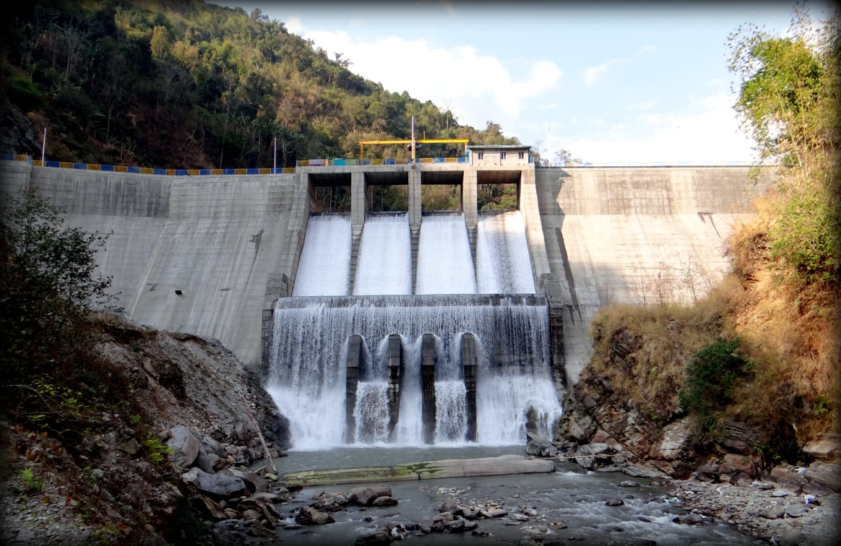
Rangpo Dam of 99 MW Chuzachen HEP(Source- M/s Gati Infrastructures Ltd).

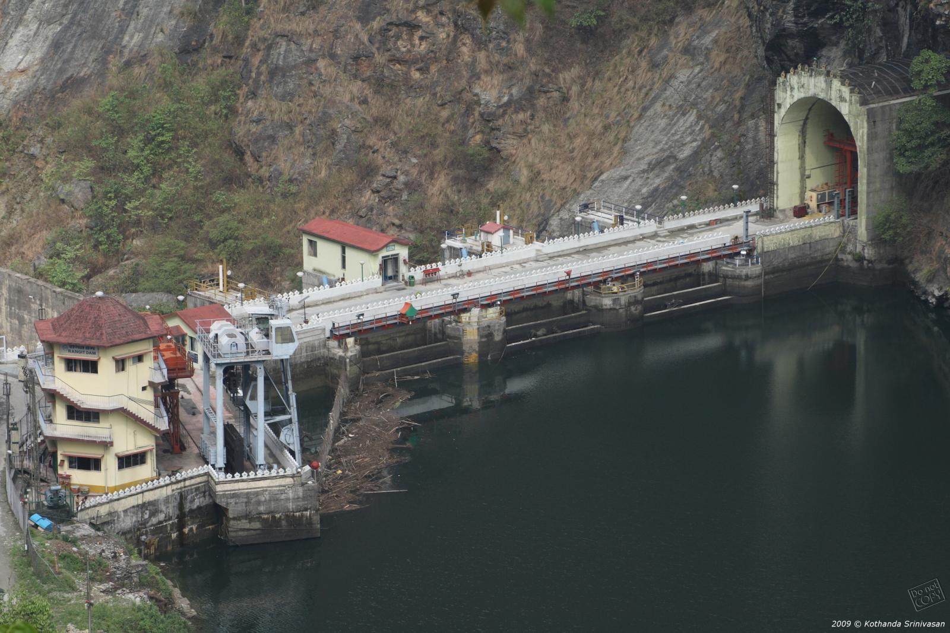
Dam of 66MW Rangit-III HEP (Source-NHPC Ltd)

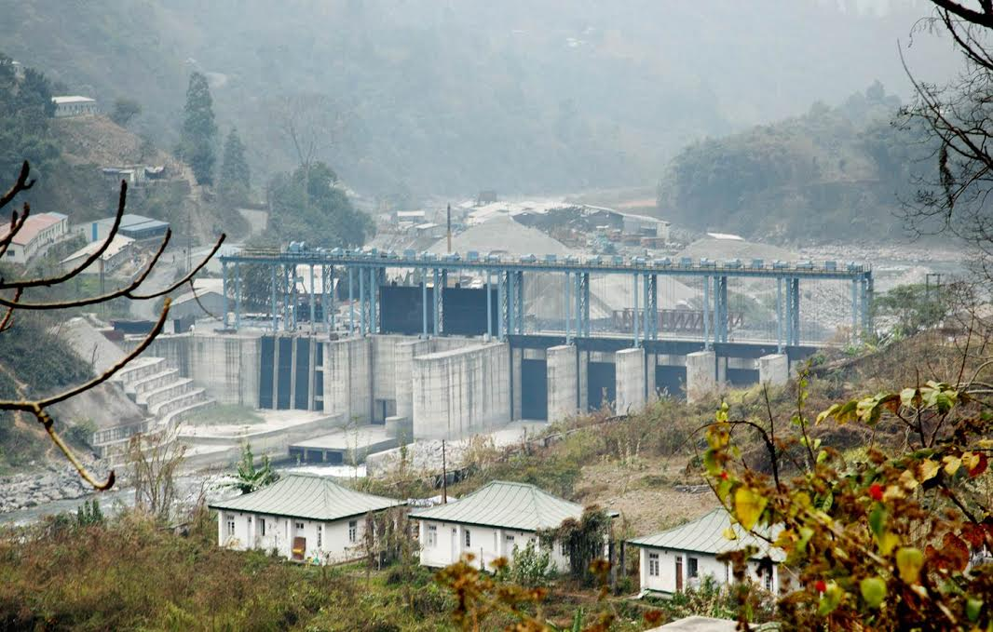
View of Barrage of 96 MW Jorethang Loop HEP (Source-DANS Energy Pvt Ltd)

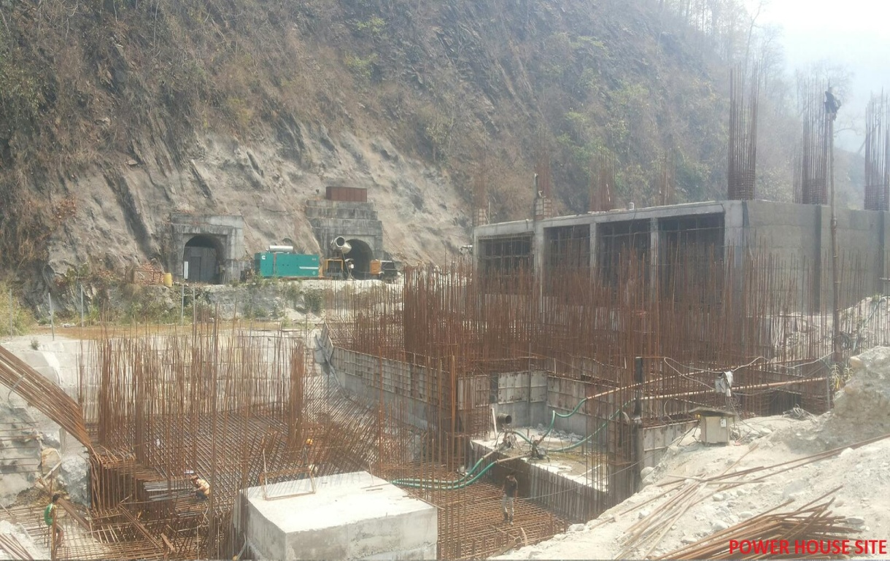
View of under-construction Powerhouse of 96 MW Rongnichu HEP.

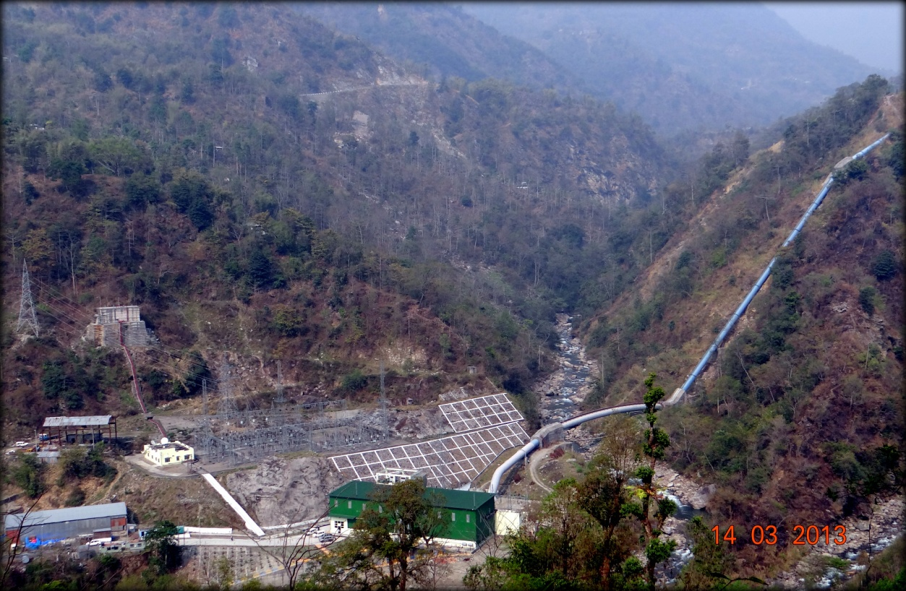
View of Power House and Penstock of 99 MW Chuzachen HEP

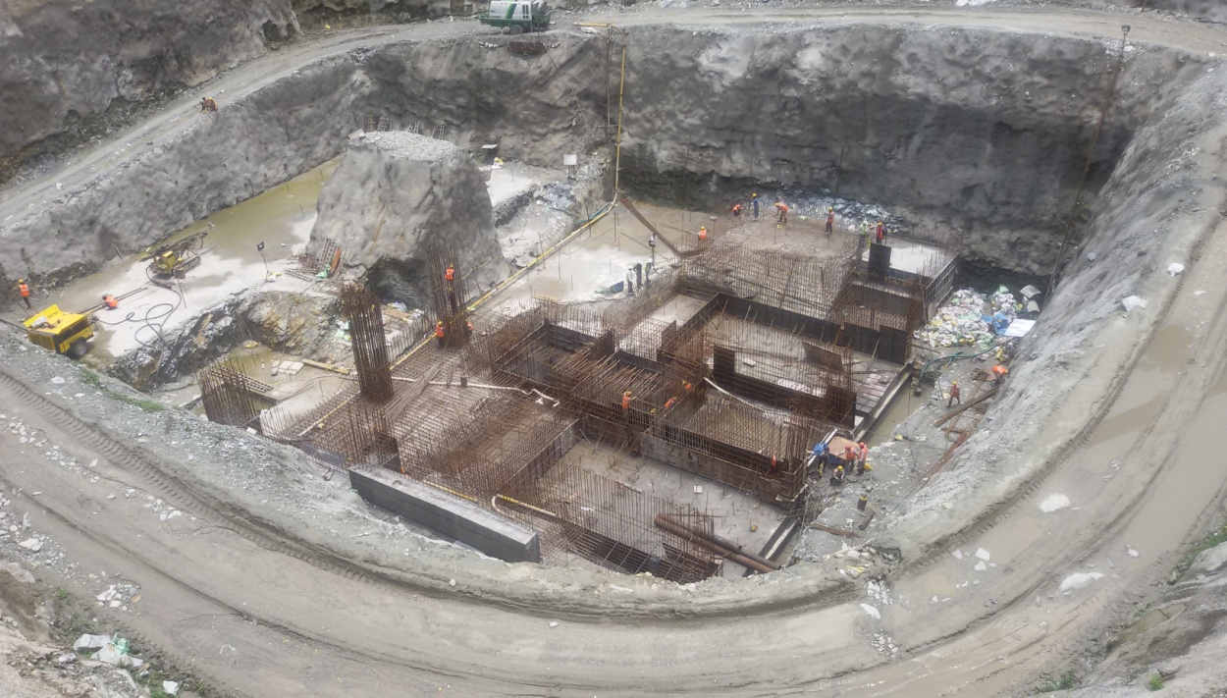
View of under-construction Powerhouse of 96 MW Tashiding HEP.

