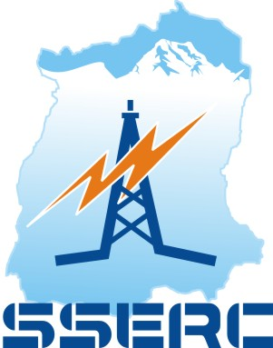

Sikkim State Electricity Regulatory Commission

ANNUAL REPORT
2018-19

July 2019

ANNUAL REPORT
2018-19

Sikkim State Electricity Regulatory Commission
Deorali,P.O-Tadong,
Gangtok, East Sikkim-737102
Phone: +91-3592-281088,Fax: +91-3592 281044
email: sikkim.serc@gmail.com
www.sserc.in

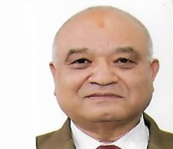
Shri N.R.Bhattarai
Chairperson
Message of the Chairperson
Sikkim State Electricity Regulatory Commission (SSERC) was constituted by the State Government in the year 2003 but the Commission had remained non-operative until the appointment of the first Chairperson in the year 2011. Thus, it can be said that the Commissionis one of the youngest Electricity Regulatory Commissions in the Country. The Commission has made strenuous efforts to catch up with its counterparts in other States, who had already started functioning, when the SSERC had just started taking baby steps. Nonetheless, the Commission has come a long way since its actual functioning started in 2011. Within a short span of little over 8 years of its coming into operation, the Commission has been able to provide the necessary regulatory frameworks for the power sector in the State. The Commission has so far framed and notified twenty two regulations including amendments thereby taking forward the regulatory processes as envisaged in the Electricity Act, 2003.
In the discharge of its duties and functions, the Commission has been guided by the principles laid out in the National Electricity Plan, National Tariff Policy and also the guidelines issued by the Government of India from time to time. The primary objective of the Commission has been providing a level playing field for stake holders in the field of electricity generation, transmission and distribution. One of the key parameters guiding the Commission is the need for bringing in efficiency&transparency in the area of power supply & distribution so that reliable and affordable power is available to the consumers. One of the key area of concern for the State has been the high AT&C losses (above 30 %), which the Commission feels is a major cause of the continuing revenue gap of the DisCom. The State Advisory Committee of the Commission has also been frequently stressing and suggesting the need for improving the power sector and bringing down the AT&C losses to the national level. The Commission has been stressing on the need for taking stringent & tangible measures by the DiscOm (Energy & Power Department, Government of Sikkim) for bringing down the losses. Some of the measures that need to be taken are pre-paid & smart metering of all consumers, feeders and Distribution Transformers metering, up-gradation of transformer capacity, introducing Aerial Bunched Cable and strengthening of the transmission & distribution network in the State and timely repair & maintenance. The Commission is keeping a close watch on the various schemes and system up-gradation works being implemented by the DisCom and is hopeful that the efforts being made by the DisCom will go a long way in improving the quality and the reliability of power supply & distribution in the State.
Setting up of Rooftop Solar Projects and Renewable Energy Generation are the two other areas that the Commission has been emphasizing especially in view of the national target of 175 GW of Renewable Energy in the country by the year 2022 and specific solar power generation targets given to each State by the Government of India. The annual power consumption of the State is growing rapidly and meeting the solar Renewable Purchase Obligation will be a challenge for Sikkim in the near future unless immediate measures are taken to boost solar power development. Reviving of old small,mini and micro hydropower projects in the State is another aspect that needs serious attention. Sikkim being a tiny State with a total consumer number of little over one lakh and coupled with the fact that the power supply & distribution businesses is being handled by a Department of the State Government, has a number of limitations and difficulties for effective implementation of the provisions of the Electricity Act, 2003. In view of the difficulties and limitations facing the Department, the Commission has been stressing upon the need for a timely decision of the State Government on un-bundling so that a clear and well planned way forward for the Department can be worked out. Nonetheless, the Commission has made all possible efforts and will keep doing so in the future to ensure that the aims and objectives as envisaged in the Electricity Act, 2003 are fulfilled.
This Annual Report is compiled as a part of the statutory provisions made in the Act and the Commission has made an attempt to give a brief insight into the activities undertaken by it during the year 2018-19.
I would like to extend our heartfelt thanks and gratitude to the State Government, Energy & Power Department, consumers and the stake holders for their constant support and cooperation and for their pro-active participation in taking forward the regulatory process. I also extend my thanks and congratulate all the Officers and staffs of the Commission for their hard work and coming out with this brief but very insightful annual report.
Gangtok Sd/-
July 2019 Nanda Ram Bhattarai
Chairperson
Contents
- Introduction
  - The Commission.
  - Objectives and Mission.
  - Mandate of the Commission.
  - Powers and Function of the Commission.
  - Annual Report of the Commission.

- Activities of The Commission for 2018-19
  - Notification of Regulations.
  - Constitution of State Advisory Committee.
  - Meeting of the State Advisory Committee.
  - Meeting with the Energy & Power Department.
  - Determination of ARR and Tariff for F.Y 2019-20.
  - Public Hearing on ARR/Tariff petition.
  - Provisional True Up/Review for F.Y 2017-18 and F.Y 2018-19.
  - Electricity Tariff for F.Y. 2018-19.

- Disputes and Grievances
  - Regulatory Disputes.
  - Grant of Licence.
  - Standards of Performance and Grievances Redressal.
  - Adjudication of Disputes and Differences.

- Annual Statement of Accounts.
  - Audited Accounts of SSERC for the F.Y. 2018-19.

- Basic Electricity Statistics.
  - Multi-year category wise consumer and connected load.
  - Growth of Energy consumption.
  - Statistics of Transmission and Distribution Losses.

- Conferences/Workshops/Seminars Capacity Building Programs

- Introduction.

  - The Commission.
The State Electricity Regulatory Commission is a mandatory requirement as per the Indian Electricity Act, 2003 (36 of 2003) to regulate the business of Power sector in the state.
Sikkim State Electricity Regulatory Commission was constituted by the State Government on the 15th day of November, 2003 vide Gazette Notification No.28/P/GEN/97/524 Dated 15.11.2003. The Commission is a one member Commission, who is the Chairperson. The Commission is functioning in its 8th year of operation since the appointment of its first Chairperson in April 2011.

  - Objectives and Mission.

The Principles forming the Objectives and Mission of the Sikkim State Electricity Regulatory Commission has been framed as per the guidelines laid out in the Electricity Act, 2003. The following are the objectives and mission of the Commission:

- To promote and protect consumer in terms of quality, reliability and reasonable pricing of a sustainable supply of electricity.
- To promote development of eco- friendly Renewable Energy Sources in line with the State’s image of a “Green State” and Eco-friendly State.
- To promote competition, efficiency and economy in bulk power matters.
- To promote investments and advice the State Government of removal of institutional barriers to bridge the demand supply gap and thus foster the interests of the consumers.
- To cultivate informed, educated and participative power consumers.
- Consistent power development planning
- To set up responsive technical standards and security compliance.
- To create a stable environment for competition and with no barriers on entry with strict and vigilant surveillance.
- To guarantee the provision of efficient and quality services to the consumers.
- To work for the reforms in the power sector to ensure supply of not only reliable, reasonably and affordable power but also to ensure the overall progress and development of the State.

The Commission is guided in discharge of its functions by the guidelines laid down in the National Electricity Policy 2005, National Electricity Plan 2004 and Tariff Policy 2006. The Commission keeps the interests of the State and the protection of the consumers paramount and mantra of transparency , good governance and the vision of the State Government of a “Green, clean and 100% Organic State”.

  - Mandate of the Commission.
- The Commission has three-fold function viz (i) Quasi-Judicial (ii) Quasi-Legislative and (iii) Executive functions.

Section 86 of the Electricity Act, 2003 mandates the following functions and powers for the State Electricity Regulatory Commissions:
- Determine tariff for electricity for generation, supply, transmission and wheeling of electricity -wholesale, bulk, grid or retail, as the case may be, within the State, in the manner provided in Section 29 of the Electricity Act, 2003.
- Regulate electricity purchases and procurement process of distribution licenses including price of purchase of power from generating companies or licensees or from other sources through agreements for power purchases distribution and supply within the State.
- Promote competition, efficiency and economy in the activities of the electricity industry to achieve the objectives and purpose of the Act.
- Regulate inter-State transmission of electricity and to determine the tariff for inter-State transmission and wheeling of electricity.
- Issue licenses to persons to function as transmission licensee, distribution licensee and electricity trader with respect to their inter-State Operations.
- Promote co-generation and generation of electricity from renewable sources of energy by providing suitable means for grid connectivity and sale of electricity from such sources, a percentage of the total consumption of electricity in the area of distribution licensee;
- Adjudicate upon the disputes between the licensees and generating companies and to refer any dispute for arbitration;
- Levy fee for the purpose of this Act;
- Specify Sate Grid Code consistent with the Grid Code specified under clause (h) of sub-section (1) of Section 79;
- Specify or enforce standards with respect to quality, continuity and reliability of service by licensees;
- Fix the trading margin in the intra-state trading of electricity, if considered necessary; and
- Discharge such other functions as may be assigned to it under this Act.

- Section 86(2) of the Electricity Act, 2003 , states that the State Commission shall advise the State Government on all or following matters, namely:

- Promotion of competition , efficiency and economy in activities of the electric industry;
- Promotion of investment in electric industry;
- re-organization and restructuring of electricity industry;
- Matters concerning generation, transmission, distribution and trading of electricity or any other matter referred to the State Commission by that Government.

- Section 86(3) of the Act states that the State Commission shall ensure transparency while exercising its power and discharging its functions.
- Section 86 (4) provides that the State Commission shall be guided by the National Electricity Policy , 2005, National Electricity Plan and Tariff Policy, 2006 published under section 3 of the Electricity Act, 2003.

1.4 Annual Report of the Commission.
Section 105 of the Electricity Act, 2003 states that,

- The State Commission shall prepare once every year in such form and at such times as may be prescribed, an annual report giving summary of its activities during the previous year and copies of the report shall be forwarded to the State Government.
- A copy of the report received under sub-section (i) shall be laid, as soon as may be after it is received, before the State Legislature.

The Annual Report for the F.Y 2018-19 has been prepared by the Commission in compliance to the above said provisions of the Electricity Act, 2003. This report has been prepared to showcase the various activities undertaken during the previous financial year and also highlight the powers, functions and roles of the Commission.

2. Activities of the Commission for 2018-19

  - Notification of Regulations.
The Commission has been empowered to make regulations, in pursuance to, under Section 181 of the Electricity Act, 2003 for the compliance of the provisions of the Act. Accordingly, the Commission has made several regulations and periodically notified them in the State Government Gazette. As per the policy decisions of the Government of India and also the guidelines issued by the same from time to time, the Commission has amended the existing regulations in adherence to the revised policies/guidelines and also notified new regulations to provide necessary regulatory framework for the power sector. The Commission has amended existing regulations and notified the following new regulations during F.Y 2018-19:
Sl  No | Regulations | Gazette Notification No. & Date
1 | Sikkim State Electricity Regulatory Commission (Levy and Collection of Fee and Charges by State Load Dispatch Centre) Regulations, 2017. | 118  19/03/2018
2 | Sikkim State Electricity Regulatory Commission (Forecasting, Scheduling, Deviation Statement and Related Matters of Wind and Solar Generation Sources) Regulations, 2018. | 240  03/05/2018
3 | Sikkim State Electricity Regulatory Commission (Recruitment and Conditions of Service of Employees) (Amendment) Regulations, 2018. | 374  27/07/2018

  - Constitution of State Advisory Committee.
The Commission, on expiry of term, re-constituted the State Advisory Committee (SAC) vide Notification No. 09/SSERC/AC/2013-14/35 Dated 01/02/2019 as per the standing provisions of section 87 of the Electricity Act, 2003 read with regulation 3(b), the Sikkim State Electricity Regulatory Commission (Constitution of State Advisory Committee and its Functions) Regulations, 2013 comprising of 7 (seven) members including the ex-Officio Chairperson. The details of the Chairperson and the Members of the Committee are as indicated below:
- Shri N.R. Bhattarai,
Chairperson of SSERC…………………………………………………..Ex-Officio Chairperson.
- Secretary, Food and Civil Supplies Department,
Government of Sikkim………………………………………………….Ex-Officio Member.
- Shri D.P. Sharma, IAS (Retd)…………………………………………Member.
- Shri N.T.Lepcha, Ex-Upa-Adakshaya(North)………………….Member.
- Shri. Uttam Kumar Pradhan, Ex-Chief Engineer…………….Member.
- Shri D.P.Deokota, Ex-Chief Engineer…………………………….Member.
- Shri B.B.Rai, Social Worker……………………………………………Member.
- Secretary, SSERC…………………………………………………………..Ex-Officio Secretary.

  - Meeting of the State Advisory Committee.
The meeting of the State Advisory Committee was conducted on the 7th of February 2019 at the SSERC Office in the presence of Hon’ble Chairperson, Members of the SAC and the Officers of the Commission. The various aspects of Power sector in regard to generation, transmission and distribution were discussed with emphasis on economy, efficiency, safety and contingencies for providing better service to all categories of consumers within the State. Various key points on the power tariff and the power scenario were deliberated upon in the meeting.
Valuable suggestions, key issues and their approach were put forward by the State Advisory Committee which provided quantum of help in finalizing of the ARR and Tariff Order for the FY 2019-20.

2.4 Meeting with the Energy & Power Department.
With regard to the Section 86 (2) of the Electricity Act, 2003, the Commission has been empowered to advise the State Government on all or any of the following matters, namely:
- Promotion of competition ,efficiency and economy in activities of the electrical industry;
- Promotion of investment in electricity industry;
- Reorganization and restructuring of electricity industry in the State;
- Matters concerning generation, transmission, distribution and trading of electricity or any other matter referred to the State Commission by the State Government.
The Commission keeping in view the above provisions of the Electricity Act, 2003, convened several rounds of meeting with the Energy & Power Department, Government of Sikkim. The purposes of the meetings/interactions with the Energy & Power Department were to deliberate upon key issues relating to power supply, distribution and generation in the State.
The Commission deliberated upon the following key issues during the meeting and observed necessary scenario and the need to resolve the issues as:
(a). Exploring options to curtail/cutting down procurement of high cost thermal power including feasibility of power banking.
(b). Un-bundling of the Department.
(c). Metering/Check of all Industrial consumers and remote sensing meters of HT consumers.
(d). Setting up of fully functional and properly manned State Load Despatch Centre.
(e). Setting up of solar power projects in the State.
(f). Improvement of the own generating capacity of the Department
(g). 100 % metering of all consumers, distribution transformers and feeders.
(h). proper monitoring of all schemes and projects under implementation to avoid time and cost overrun.
(i). Adhere to the various milestones agreed upon by the State in the Memorandum of Understanding (MoU) executed with the Government of India for schemes like UDAY,etc.
(j). need for conducting/organizing public awareness campaigns on safety, energy efficiency, consumer grievance redressal and various provisions of the Electricity Act, 2003 and other standing rules/regulations.

  - Determination of ARR and Tariff for F.Y 2019-20.
The Energy & Power Department, Government of Sikkim, the deemed licensee for distribution of power in Sikkim filed its petition for Annual Revenue Requirement and Tariff before the Commission for the F.Y. 2019-20 on 29.11.2018 and the same was accepted and registered as Case No. MYT/2019-20/P-01 on 12.12.2019.

The Commission further held a series of communications and interactions with the Energy & Power Department on the requisite clarifications and additional information/data were sought from the Department pertaining to the ARR/Tariff petition.

2.6 Public Hearing on ARR/Tariff 2019-20 petition.
As mandated by the Electricity Act, 2003, the deemed Distribution Licensee for electricity in the State i.e. the Energy and Power Department, Government of Sikkim filed its petition before the Commission for approval of the Annual Revenue Requirement and Tariff Petition for the F.Y 2019-20 on the 29th of November 2019.

The Commission conducted an open Public Hearing on the Annual Revenue Requirement and Tariff Petition for the F.Y 2019-20 filed by the Department on 28th February 2019. The Commission also issued Public Notices in the local newspapers soliciting views, suggestions, objections and comments of the general public and stake holders on the petition filed by the Department. However, no any comments/objections and suggestions were received from the public. Further, there was hardly any participation by the public in the hearing except for one lone individual. The Commission deemed it fit to continue with the hearing process and the views, comments, suggestions etc of the lone participant admitted and heard by the Commission.

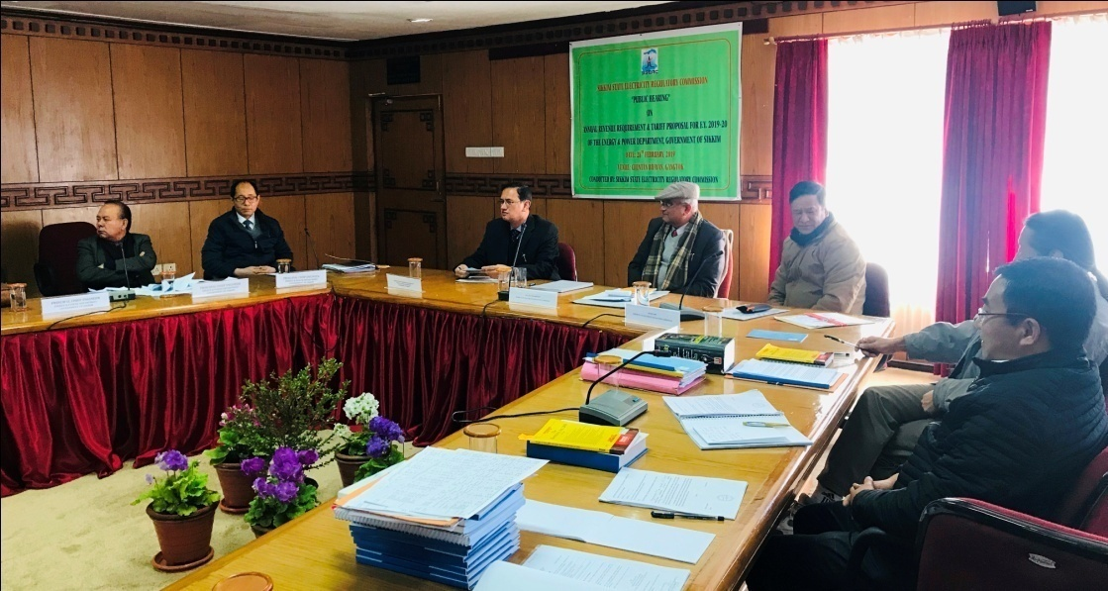

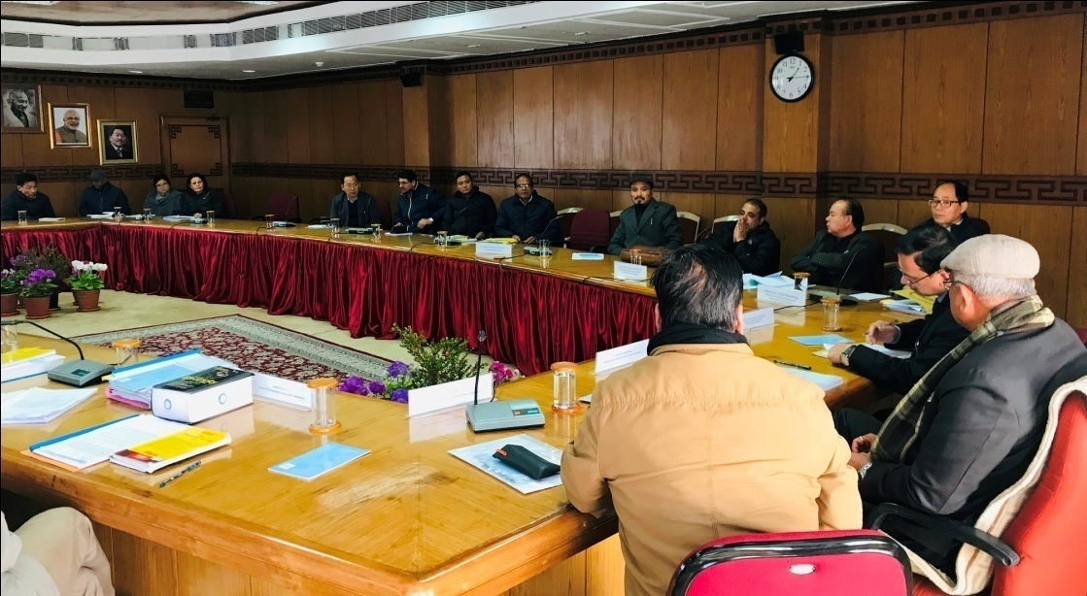
Public Hearing held at Chintan Bhawan, Gangtok.

  - Provisional True Up/Review for F.Y 2017-18 and F.Y 2018-19

The Commission after prudence check and detailed scrutiny of the Petition filed by the Energy & Power Department for Provisional True Up for F.Y 2017-18 and Review for F.Y 2018-19, carried out the Provisional Truing Up/Review and considered the same.

ARR and Revenue Gap approved by the Commission for F.Y. 2017-18 (provisional True Up)

Sl.No | Particulars | Approved by the Commission (Rs.Cr) | Actuals furnished by EPDS (Rs.Cr) | Revised approved by Commission after True Up (Rs.Cr)
1 | Cost of Fuel | 0.18 | 0.12 | 0.12
2 | Cost of Power Purchase | 226.25 | 242.04 | 242.04
3 | Employee Costs | 106.19 | 94.86 | 94.86
4 | R&M Expenses | 21.80 | 28.03 | 28.03
5 | Admn & Gen. Expenses | 1.14 | 5.19 | 5.19
6 | Depreciation | 21.76 | 26.93 | 19.18
7 | Int & Fin Charges | 0.00 | 0.00 | 0.00
8 | Int on W.C. | 7.74 | 11.01 | 10.19
9 | Return on NFA/Equity | 0.00 | 0.00 | 0.00
10 | Total ARR | 385.06 | 408.18 | 399.61
11 | Less: Non Tariff Income | 1.55 | 1.42 | 1.42
12 | Net ARR | 383.51 | 406.76 | 398.19
13 | Revenue from Tariff | 179.57 | 194.95 | 194.96
14 | Revenue from outside sales | 86.46 | 182.59 | 182.59
15 | Gap | 117.48 | 29.21 | 20.64

Provisional True Up for the FY 2017-18 indicated that the revenue gap has been reduced to Rs. 20.64 crores as against Rs.117.48 Crores for FY 2017-18.

Aggregate Revenue Requirement and Gap for FY 2018-19 (Review)
Sl.No | Particulars | Approved by the Commission (Rs.Cr) | Actuals furnished by EPDS (Rs.Cr) | Revised approved by Commission after True Up (Rs.Cr)
1 | Cost of Fuel | 0.18 | 0.18 | 0.18
2 | Cost of Power Purchase | 18.48 | 18.48 | 18.48
3 | Employee Costs | 222.89 | 260.90 | 260.90
4 | R&M Expenses | 40.80 | 40.80 | 40.80
5 | Admn & Gen. Expenses | 78.78 | 76.95 | 76.95
6 | Depreciation | 13.95 | 20.42 | 20.42
7 | Int & Fin Charges | 0.85 | 3.63 | 3.63
8 | Int on W.C. | 16.41 | 18.60 | 16.41
9 | Return on Equity | 0.00 | 0.00 | 0.00
10 | Total ARR | 400.01 | 451.01 | 444.45
11 | Less: Non Tariff Income | 1.59 | 1.59 | 1.59
12 | Net ARR | 398.42 | 449.43 | 442.86
13 | Revenue from Tariff | 202.43 | 212.20 | 210.05
14 | Revenue from outside sales | 114.04 | 191.72 | 200.39
15 | Gap | 81.95 | 45.51 | 32.42

Review for the FY 201-19 indicates that the revenue gap has been reduced to Rs. 32.42 crores as against Rs.81.95 Crores for FY 2018-19.

2.8 Electricity Tariff for F.Y. 2018-19.
Sl  No. | Category of Consumers | Monthly Minimum Charges (Rs/Consumer) | Demand Charges (HT Supply only) (Rs/KVA/Month) |  | Approved Energy Charges (Paisa/KWH)
1 | Domestic
a) | Up to 50 units | Single Phase – 40/-  3 Phase – 200/- |  |  | 110
b) | 51 to 100 units |  |  |  | 234
c) | 101-200 units |  |  |  | 365
d) | 201 to 400 units |  |  |  | 457
e) | 401 & above |  |  |  | 493
2 | Commercial |  | Load > 25KVA on shared Transformer
a) | Up to 50 units | Single Phase – 200/-  3 Phase – 500/- |  |  | 330
b) | 51 to 100 units |  | Rural | Urban | 560
c) | 201 to 400 units |  | 60/- | 100/- | 600
d) | 401 & above |  |  |  | 640
3 | Public lighting
 | Rural Areas |  |  |  | 300
 | Urban Areas |  |  |  | 500
4 | Industrial
A | HT (AC) above 3.3 KV
a) | Up to 100 KVA | … | 200/- |  | 350
b) | 100 - 250 KVA | … | 250/- |  | 400
c) | 250- 500 KVA | .. | 290/- |  | 470
d) | 500 KVA & above | … | 555/- |  | 510
B | LT (Rural)
a) | Up to 500 units | 120/- | 60/- (>25KVA) on shared Transformer |  | 350
b) | 501 - 1000 units |  |  |  | 440
c) | 1001 & above |  |  |  | 580
C | LT (Urban)
a) | Up to 500 units | 200/- | 100/- (>25KVA) on shared Transformer |  | 530
b) | 501 - 1000 units |  |  |  | 620
c) | 1001 & above |  |  |  | 715
5 | Bulk supply
a) | LT | 200/- |  |  | 650
b) | HT |  |  |  | 660

3. Disputes and Grievances

3.1 Regulatory Disputes
There were no regulatory disputes during the Financial Year 2018-19.
3.2 Grant of Licence
The SSERC did not grant any licence during the period from April 2018-March 2019.
3.3 standards of performance and grievance redressal
The Commission has monitored the compliance to the standard of performance by the deemed licensee i.e. Energy & Power Department, Government of Sikkim and also monitored the redressal of grievances by the Consumer Grievance Redressal Forum (CGRF) and Ombudsman.
The details of grievances and redressal during the FY 2014-15 are as given below:

Electricity Ombudsman
No. of Grievances Received | No. Of Grievances Disposed Off | No. Of Pending Cases.
Nil | Nil | Nil
Consumer Grievance Redressal Forum, Gangtok, East Sikkim.
No. of Grievances Received | No. Of Grievances Disposed Off | No. Of Pending Cases.
Nil | Nil | Nil

3.4 Adjudication of disputes and differences
No any cases of differences or disputes were reported before the Commission during the FY 2018-19.

- Annual Statement of Accounts.

  - Audited Accounts of SSERC for the F.Y. 2018-19.
SIKKIM STATE ELECTRICITY REGULATORY COMMISSION
GANGTOK, SIKKIM

BALANCE SHEET AS AT 31ST MARCH, 2018
 | Schedule | As on 31.03.2018  Amount (Rs) | As on 31.03.2017  Amount (Rs)
CAPITAL FUND AND LIABILITY  CORPUS FUND  CURRENT LAIBILITIES  TOTAL | 1  2 | 15,382,792.57  1,026,545.00 | 20,389,218.57  1,617,733.00
 |  | 16,409,337.57 | 22,006,951.57
APPLICATION OF FUND  FIXED ASSETS  INVESTMESNTS  CURRENT ASSETS, LOANS & ADVANCES  ADVANCES  BANK BALANCE  CASH BALANCE  TOTAL  NOTES ON ACCOUNTS | 6  3  4  5  10 | 5,628,486.00  5,000,000.00  373,000.00  5,407,851.57  -  16,409,337.57  - | 5,778,844.00  2,768,257.00  473,875.00  12,974,258.57  11,717.00  22,006,951.57  -

IN TERMS OF OUR REPORT OF EVEN DATE
For Pravin K Agarwal & Co. Sd/-
Chartered Accountants Chairperson

Sd/- Sd/-
(Pravin Kr. Agarwal) Financial Advisor
Proprietor
M. No. 511455

Place: Gangtok Sd/-
Date: 17.07.2018 SecretarY

SIKKIM STATE ELECTRICITY REGULATORY COMMISSION
GANGTOK, SIKKIM

STATEMENT OF INCOME AND EXPENDITURE FOR THE YEAR ENDED ON 31.03.2018

INCOME  GRANT IN AID FROM GOVERNMENT  FEES RECEIVED  OTHER INCOME  TOTAL  EXPENDITURE  ESTABLISHMENT EXPENSES  ADMINISSTRATIVE EXPENSES  DEPRECIATION  AUDIT FEES  TOTAL  SURPLUS/ DEFICIT FOR THE YEAR  ADJUSTMENT/ PRIOR PERIOD EXPENSES  BALANCE OF EXCESS/ DEFICIT) TRANSFERRED TO CAPITAL FUND  NOTES ON ACCOUNTS | Schedule  7  8  9  6  10 | For the year ended  31.03.2018  Amount(Rs)  13,500,000.00  561,000.00  528,553.00 | For the year ended  31.03.2017  Amount (Rs)  13,500,000.00  564,000.00  636,033.00
 |  | 14,589,553.00 | 14,700,033.00
 |  | 14,130,072.00  4,339,169.00  1,079,538.00  47,200.00 | 11,815,047.00  5,233,854.00  1,309,930.00  47,200.00
 |  | 19,595,979.00 | 18,406,031.00
 |  | (5,006,426.00)  -- | (3,705,998.00)  ---
 |  | (5,006,426.00) | (3,705,998.00

IN TERMS OF OUR REPORET OF EVEN DATE

For Pravin K Agarwal & Co. Sd/-
Chartered Accountants Chairperson

Sd/- Sd/-
(Pravin Kr. Agarwal) Financial Advisor
Proprietor
M. No. 511455

Sd/-
Place: Gangtok Secretary
Date: 17.07.2018

- Basic Electricity Statistics.

5.1 Multi-year category wise consumer and connected load.
Sl. No | Category | 2017-2018 (Actual) |  | 2018-2019 (Estimated) |  | 2019-2020 (Projected)
 |  | No. of Consumer | Energy Sale /Demand (MUs) | No. of Consumer | Energy Sale /Demand (MUs) | No. of Consumer | Energy Sale /Demand (MUs)
1 | Domestic | 97002 | 98.72 | 98942 | 106.85 | 100339 | 111.26
2 | Commercial | 11356 | 38.38 | 11583 | 40.33 | 11686 | 41.14
3 | Public Lighting | 36 | 0.17 | 37 | 0.28 | 38 | 0.29
4 | Temporary |  | 3.38 |  | 1.60 |  | 3.38
5 | Industrial HT | 552 | 174.43 | 534 | 192.78 | 548 | 215.33
6 | Industrial LT | 576 | 4.43 | 582 | 4.65 | 588 | 5.67
7 | Bulk supply | 1816 | 24.16 | 1852 | 25 | 1900 | 28.00
Total |  | 111,338 | 343.67 | 113,530 | 371.49 | 115,099 | 405.08

5.2 Growth of Energy Consumption
Sl. No | Category | 2017-2018  (Actual)  (% of Demand) | 2018-2019  (Estimated)  (% of Demand) | 2019-2020  (Projected)  (% of Demand)
1 | Domestic | 28.72 | 28.76 | 27.5
2 | Commercial | 11.16 | 10.85 | 10.15
3 | Public Lighting | 0.05 | 0.08 | 0.07
4 | Temporary | 1 | 0.43 | 0.83
5 | Industrial HT | 50.75 | 51.9 | 53.15
6 | Industrial LT | 1.3 | 1.25 | 1.4
7 | Bulk supply | 7.02 | 6.73 | 6.9
Total |  | 100 | 100 | 100

5.2 Statistics of Transmission and Distribution Losses.
Sl. No | Transmission and Distribution Losses in the year | Loss in %
1 | 2017-2018 | 32.09 %
2 | 2018-2019 | 24.00 %
3 | 2019-2020 (Projected) | 24.67%

- Conferences/Workshops/Seminars Capacity Building Programs
The Commission being member of the various forums like the Forum of Regulators (FOR), Forum of Electricity Regulators for Eastern and North -Eastern States (FORENS), South Asian Forum of Infrastructure Regulators (SAFIR) has been attending training programs and workshops by nominating the Officers of the Commission to attend various programs being conducted by such Forums in different parts of the country and abroad. Workshops and training programs attended by the Officers of the Commission are as under:

- Committee for International Council on Large Electric System (CIGRE, 26th Aug – 7th Sept 2018, Paris)
- 10th Meeting of FORENS (25th-27th October 2018, Bodhgaya, Bihar)
- 65th Meeting of FOR (12th-13th November 2018, Bhubaneswar, Orissa)
- International Conference on Global Energy Transition – Issues and challenges.
(24th-25th May 2018, Gangtok, Sikkim)

